Quadrilaterals-Questions
Key Stage 3: 2003 Paper 1 Level 5-7
1.
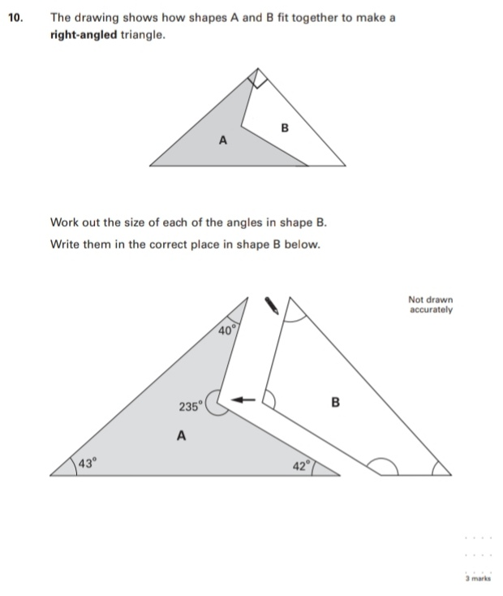
Key Stage 3: 2003 Paper 1 Level 6-8
2.
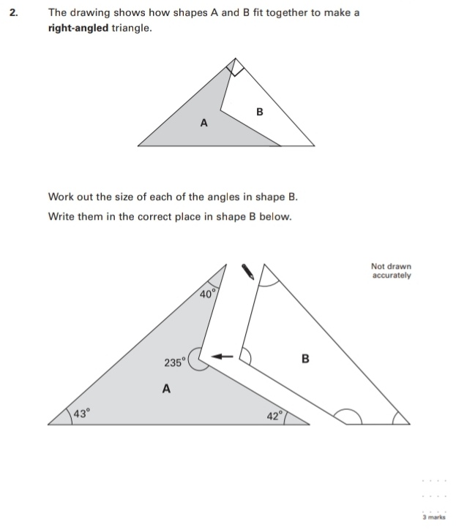
Key Stage 3: 2004 Paper 2 Level 5-7
3.
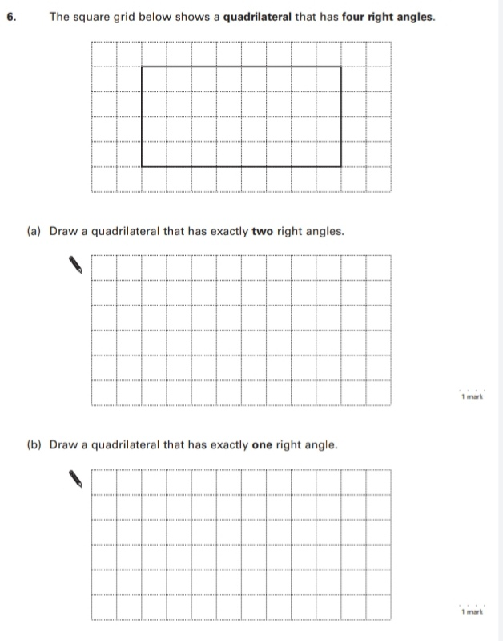
Key Stage 3: 2011 Paper 1 Level 5-7
4.
